MINISTRY OF EDUCATION AND TRAINING
CAN THO UNIVERSITY
COLLEGE OF INFORMATION AND COMMUNICATION TECHNOLOGY



GRADUATION THESIS
BACHELOR OF ENGINEERING IN
INFORMATION TECHNOLOGY
(HIGH-QUALITY PROGRAM)

DEVELOPING A MUSHROOM RECOGNITION APPLICATION

Student: Nguyễn Quang Vinh
Student ID: B2105727
Class: 2021-2025 (K47)
Advisor: Dr. Bùi Võ Quốc Bảo

Can Tho, 12/2025
MINISTRY OF EDUCATION AND TRAINING
CAN THO UNIVERSITY
COLLEGE OF INFORMATION AND COMMUNICATION TECHNOLOGY
DEPARTMENT OF INFORMATION TECHNOLOGY

GRADUATION THESIS
BACHELOR OF ENGINEERING IN
INFORMATION TECHNOLOGY
(HIGH-QUALITY PROGRAM)

DEVELOPING A MUSHROOM RECOGNITION APPLICATION

Student: Nguyễn Quang Vinh
Student ID: B2105727
Class: 2021-2025 (Cohort K47)
Advisor: Dr. Bùi Võ Quốc Bảo

Can Tho, 12/2025

COMMENTS OF INSTRUCTOR
.......................................................................................................................................
.......................................................................................................................................
.......................................................................................................................................
.......................................................................................................................................
.......................................................................................................................................
.......................................................................................................................................
.......................................................................................................................................
.......................................................................................................................................
.......................................................................................................................................
.......................................................................................................................................
.......................................................................................................................................
.......................................................................................................................................
.......................................................................................................................................
.......................................................................................................................................
.......................................................................................................................................

Can Tho, ………………………. 2025

Advisor

Ph.D. Bui Vo Quoc Bao

ACKNOWLEDGEMENTS
First of all, I would like to express my deep gratitude to Professor Bui Vo Quoc Bao, lecturer at the School of Information and Communication Technology. As an advisor, he has spent a lot of time guiding, orienting and supporting me throughout the process of researching and implementing the thesis.
I also sincerely thank all the teachers at the School of Information and Communication Technology who have provided me with basic and specialized knowledge throughout the learning process, helping me to complete this thesis.
Finally, I would like to thank my family and friends - those who have always been there to cheer me up and encourage me, helping me overcome difficulties and pressures throughout the process of studying and writing this thesis.
Although I have tried my best to complete the topic on time, due to the limitation of time and practical experience, the thesis certainly cannot avoid shortcomings. I look forward to receiving comments from teachers and friends to help my topic be more complete.

Can Tho, ………………………. 2025
Student

Nguyen Quang Vinh

TABLE OF CONTENTS

COMMENTS OF INSTRUCTOR 3
ACKNOWLEDGEMENTS 4
LIST OF FIGURES 6
LIST OF TABLES 7
LIST OF ACRONYMS 8
ABSTRACT 9
CHAPTER 1: INTRODUCTION 10
1.1 . PROBLEM DESCRIPTION 10
1.2. PURPOSE OF THE STUDY 10
1.3. THESIS OBJECTIVES AND SCOPE 11
1. Research Objectives 11
2. Research Scope 11
1.4. THESIS CONTENT 11
1.5. RELATED WORKS 13
1.6. OUTLINE OF THE STUDY 13
CHAPTER 2: THEORETICAL BACKGROUND, TECHNOLOGIES AND METHODOLOGY 14
2.1. DEEP LEARNING 14
2.2. CONVOLUTIONAL NEURAL NETWORKS (CNNs) 15
2.3. VISION TRANSFORMERS (ViT) 15
CHAPTER 3: IMPLEMENTATION 22
CHAPTER 4: CONCLUSION AND DEVELOPMENT DIRECTION 23
4.1. CONCLUSION 23
4.2. DEVELOPMENT DIRECTION 23
REFERENCE 24

LIST OF FIGURES
Figure 1: A typical CNN architecture [1] 15
Figure 2: A typical ViT architecture [2] 15

LIST OF TABLES
< 1 page reserved for a table of content>

LIST OF ACRONYMS

No. | Acronym | Meaning
1 | ViT | Vision Transformers
2 | CNN | Convolutional neural networks
3 | API
4 | AI
5 | MLP
6 | UI
7 | IDE
8 | IEEE
9 | 1D
10 | 2D

ABSTRACT
The accurate identification of mushroom species is challenging due to visual similarities between edible and toxic varieties, posing significant health risks from misidentification. This thesis develops a mobile application employing a hybrid AI model to provide reliable recognition tools with a precision of at least 90% based on the mushroom type.
The primary contribution to the thesis is a hybrid deep-learning architecture integrating Vision Transformers (ViT) and Convolutional Neural Networks (CNNs). This hybrid model captures local features and global contextual information from images, achieving high classification accuracy. The system uses a client-server framework: the mobile app enables image capture or upload, transmitting data to a remote server for inference by the hybrid model, which returns results and details in near real-time.
The application integrates deep learning into an accessible mobile platform, serving as an advisory tool for beginners to enhance decision-making safety. It demonstrates the efficacy of hybrid AI in mobile visual recognition and offers a scalable basis for advancing automated species identification.

CHAPTER 1: INTRODUCTION

1.1 . PROBLEM DESCRIPTION
The identification of mushroom species has traditionally relied on methods such as field guides, visual comparison, and consultation with experts. While effective in many cases, these approaches often demand a considerable level of prior knowledge about the subject yet it can still lead to misclassification, especially for beginners. Many mushroom species display subtle similarities in features such as cap shape, color patterns and gill structure, making cases of misidentification common without experience. With thousands of documented species worldwide and numerous toxic varieties that closely resemble edible ones, misidentification continues to pose risks that range from mild discomfort to severe poisoning or even death.
With the growing interest in outdoor activities, hobbyist foraging has increased the demand for accessible tools to assist beginners. Modern smartphones combined with advancements in artificial intelligence provide an opportunity to support these users by enabling quick, intuitive identification based on photographic input. Mobile systems powered by deep learning models can analyze images, highlight key characteristics, and deliver immediate feedback that guides users toward safer decisions.
This thesis focuses on developing such a system, designed primarily for beginners and hobbyists seeking an approachable way to identify mushrooms. The application operates within a client–server framework in which users capture or upload images, send them to a remote server for inference, and receive detailed results including candidate species, basic descriptions, edibility information, and warnings about harmful look-alikes. Rather than replacing expert knowledge, the system aims to offer initial guidance that helps users become more informed, avoid dangerous specimens, and pursue further learning when needed.
By integrating practical mobile technology with modern computer vision techniques, this work contributes to safer recreational foraging and broader public engagement with mycology. The platform is designed to evolve alongside future improvements in deep learning, supporting long-term applicability in education, environmental awareness, and community health.

1.2. PURPOSE OF THE STUDY
The purpose of this study is to develop “FungiScan”, a free and user-friendly mobile application designed to assist beginners, hobbyists, and outdoor enthusiasts in identifying mushroom species quickly and reliably. The system aims to reduce reliance on prior expertise by integrating deep learning–based image recognition within an intuitive interface that enables simple image input, server-side processing, and instant delivery of results. Through accessible design and accurate species analysis, the application supports safer foraging practices and broadens public engagement with mycology by helping users recognize potential risks, distinguish edible varieties from toxic look-alikes, and explore relevant ecological information.

1.3. THESIS OBJECTIVES AND SCOPE

1. Research Objectives
- Developing the FungiScan mobile application capable of identifying mushroom species through user uploaded images.
- Providing a free and easy to use mushroom identification tool for beginners and hobbyists.
- Researching and implementing deep learning technologies combining CNN and ViT for an improved image recognition models.
- Designing and building a client-server architecture to ensure real-time image processing and quick results.

2. Research Scope
- Developing “FungiScan” as a mobile application for the Android platform, supporting global users with active internet connection.
- The server system handles AI inference, receives images from mobile devices and returns information on mushroom species, edibility, habitat, toxicity warnings and other relevant details.

1.4. THESIS CONTENT
The thesis is organized around the complete development process of the FungiScan mobile application and its supporting server-side AI system. The main implementation phases include:
- Requirement Analysis:
  - Researching and collecting functional requirements for a mobile mushroom identification system and the server infrastructure supporting remote AI inference.
  - Analyzing essential components of image-based species recognition workflows (mobile-side image capture, preprocessing, and server-side model prediction)
  - Researching deep learning architectures that combine CNN and ViT, mobile development frameworks, API communication methods, and deployment environments suitable for real-time inference.

- Design:
- Developing functional requirement diagrams and use-case models describing interactions between users, the mobile application, and the server.
- Creating UI wireframes and interaction flows focusing on intuitive image selection, upload, prediction result presentation, and browsing of identification history.
- Designing a local storage schema for inference history and prepare a JSON file to stored mushroom information to be used entirely on-device; create architecture diagrams for the client–server communication model.
- Implementation:
- Developing the Android application using the Flutter framework and Dart language, integrating camera/gallery access, permission handling, local storage, and network communication with Flutter packages.
- Implementing server-side AI inference using Python and PyTorch, deploying the hybrid ViT + CNN model on the Lightning.ai platform for scalable execution.
- Implementing the prediction API using LitServe and FastAPI to receive image data, preprocess inputs, perform inference, and return only the predicted class index to the client.
- Use Android Studio for all mobile development tasks and Lightning.ai’s built-in Jupyter Notebook IDE for model development, server scripting, and API deployment.
- Conduct real-device testing for both app functionality and API interaction to ensure accurate performance under real-world conditions.
- • Technology Used
- Mobile Frontend: Flutter and Dart, with supporting packages.
- Backend & AI: Python, PyTorch, FastAPI, LitServe, hybrid ViT+CNN model.
- Local Database: SQLite for storing inference history on-device. Mushroom information stored entirely in a JSON file on the device, enabling the app to map predicted classes to species descriptions without requiring the server to return metadata.
- Deployment: Lightning.ai for hosting, model execution, and API service.
- Design Tools: PowerDesigner and StarUML for diagrams.
- Development Tools: Android Studio for mobile development; Lightning.ai Jupyter Notebook IDE for training, inference scripts, and API development. Kaggle for model training and validation.
- Testing Tools: Physical Android devices for application testing.

1.5. RELATED WORKS
Several mobile applications have been developed for mushroom identification on the Android platform, using computer vision and machine learning to assist users in fungi recognition. Notable examples include “Picture Mushroom – Mushroom ID” by Next Vision Limited and “Mushroom Identification” by Battery Stats Saver. While these applications demonstrate practical utility in field settings, they often rely on subscription-based models, which may impose hefty monthly fees or limit the number of free identifications. This can restrict access for casual users, hobbyists, and beginner foragers. Additionally, many existing apps prioritize functionality over simplicity, making the interface less intuitive for beginners. The FungiScan app addresses these gaps by offering a completely free platform with a simple, user-friendly interface that allows quick mushroom identification, immediate feedback on edibility, and safety guidance for potentially toxic species.

1.6. OUTLINE OF THE STUDY
The structure of this thesis is organized as follows:
- Chapter 1: Introduction – Presents the research problem, purpose of the study, objectives, scope, related works, and an overview of the thesis content.
- Chapter 2: Theoretical background, technologies, and methodology.
  - Part 1: General introduction to the topic, system specifications, and core functions.
  - Part 2: Solution design, theoretical foundations, technologies used, use-case diagrams, database design, and detailed functional descriptions of each system component.
  - Part 3: This could be talking about the technologies used actually
- Chapter 3: Implementation and Testing – Covers the installation of the solution, implementation results, system evaluation, and testing. Includes descriptions of test objectives, scenarios, and results.
- Chapter 4: Conclusion and Future Work – Summarizes the achievements, highlights contributions, and proposes directions for future improvements and expansions.

CHAPTER 2: THEORETICAL BACKGROUND, TECHNOLOGIES AND METHODOLOGY
I. Phần công nghệ sử dụng
2.1. Related Technologies and Libraries
2.1.1 PyTorch
2.1.2 Transformers (HuggingFace)
2.1.3 timm
2.1.4 scikit-learn (for external classifiers)
2.1.5 Albumentations (augmentation + preprocessing)
2.1.6 Matplotlib (visualization)
2.1.7 CUDA (GPU acceleration)
2.1.8 Lightning.ai (server deployment)
2.1.9 LitServe + FastAPI (inference API)
2.1.10 Flutter/Dart (mobile frontend)
2.1.11 SQLite & JSON (local data storage in the app)
2.1.12 OpenStreetMap

II. Phần App
2.9. System Architecture and Application Design
2.9.1. System Architecture Overview
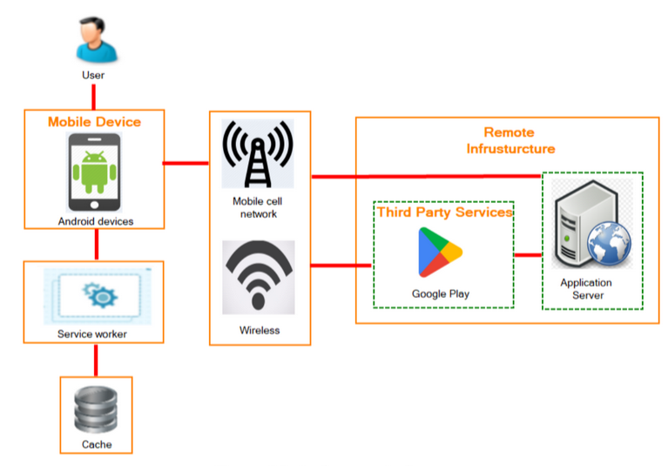
THIS IS A SAMPLE MAKE ONE TO REFLECT THE CURRENT APP
2.9.2 Main functions of the system
(inference, history, theme and shit, short and simple)
2.9.3. Use Case Diagram
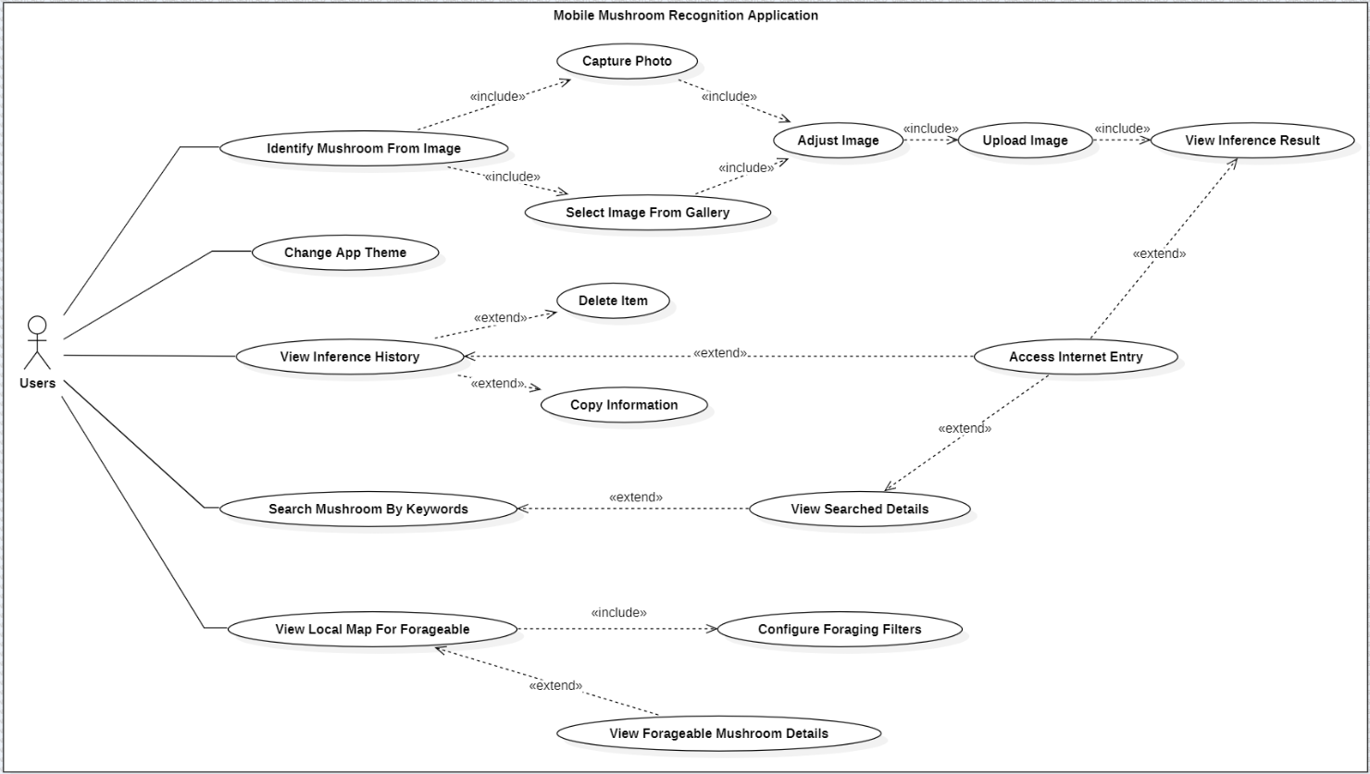
Users don't need to log into to use at all. The first screen they can see after opening the app is the home screen, this is where they can choose to either upload mushroom image from gallery or take a photo, they will then be taken to a screen to resize and rotate the image (ensure that the mushroom is at the focal point for the inference process), then hit "ok" to upload the image to the server to be infer. Then they are taken to a page that display the inference result (which is also saved to local storage), here they can either hit ok to close that screen and return to the home screen or tap on the "open link" icon on the top bar to go to Wikipedia of that mushroom.

The second screen is the history screen, where past inference result (user uploaded) is stored and display in items (they can choose to sort by name or date of inference as well as reload the page on the top bar). The items in the history screen can be tap to lead them to view the inference result (same result and also contain the link to Wikipedia for the mushroom as well).

The third screen is the Search screen, where they can look up a mushroom my typing in keywords about the mushroom (be it about physical characteristic, smell, habitat, name, etc.) to find the mushroom (the data is pull from a json file). The look up result is shown in items that user can click on to view details about (also contain link to Wikipedia)

The final screen is the forage map, where the app will take user location (latitude and longitude) and other info like (Mushroom only/all species, number of species shown, radius and month) to show available species around them that either can be forage to eat or avoid, each will be shown as a marker on a map that can be tap on to be shown name of species, image and date of upload (all of which are pull from the Inaturalist API). Users can change the input radius, the limit (number of species shown), the month (auto detect but user can change this) and whether to view All species around them or only mushroom.
Keep this short, focus on the features not details

2.9.4. MAIN FUNCTION OF THE SYSTEM
2.9.4.1. Home screen/Inference/Identify mushroom from image
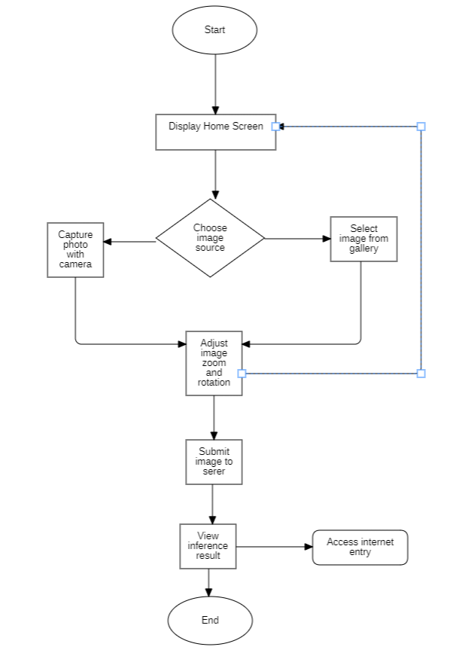
The first screen they can see after opening the app is the home screen, this is where they can choose to either upload mushroom image from gallery or take a photo, they will then be taken to a screen to resize and rotate the image (ensure that the mushroom is at the focal point for the inference process), then hit "ok" to upload the image to the server to be infer. Then they are taken to a page that display the inference result (which is also saved to local storage), here they can either hit ok to close that screen and return to the home screen or tap on the "open link" icon on the top bar to go to Wikipedia of that mushroom.
2.9.4.1. History screen
2.9.4.1. Search screen
2.9.4.1. Forage map
2.9.5. API Flow
(image upload → inference → class index response)
(How the Inaturalist API works)
2.9.6. Local Database Design
SQLite table structure
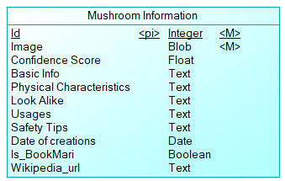
No | Field name | Data type | Description
1 | Id | ObjectID | Entry ID
2 | Image | object | User uploaded image
3 |  | Double
4 |  | string
5 |  | string
6 |  | String
7 |  | String
8 |  | String
9 |  | Date
10 |  | Bool
11 |  | string

JSON format for mushroom metadata
I don’t know what to say here

How predicted-class index maps to metadata
I don’t know what to say here

2.9.7. Mobile App UI/UX Overview
a. Nav bar

Where user fucking nav around I guess
b. homescreen
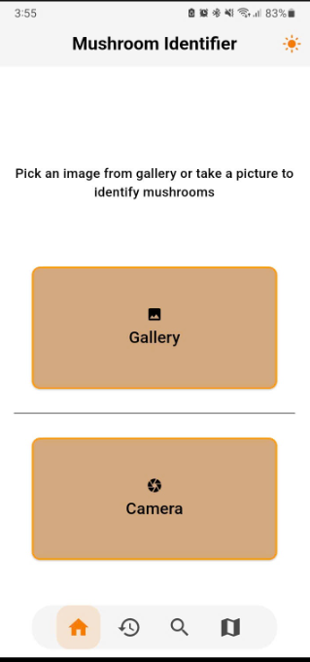
Fuck you
C
D
E
F

III. Phần AI

2.1. DEEP LEARNING

Deep learning is a subfield of machine learning that draws inspiration from biological neural systems. It uses multiple layers of artificial neural networks to automatically learn meaningful patterns extracted from raw data. With each layer capturing increasingly abstract features of the input. The data flows from the input layer through multiple hidden layers, where nonlinear transformations are applied. Before reaching the output layer to generates the final prediction. The network's depth, often ranging from tens to hundreds of layers or more, enables it to learn complex relationships that simpler models cannot. These models are typically trained on large datasets using gradient-based optimization and backpropagation, allowing the network to iteratively adjust its internal parameters and improve performance.
With increase in GPU computational powers since the early 2010s, the availability of larger datasets, and breakthroughs to solve problems such as vanishing gradients, deep learning achieved a state-of-the-art performance across image classification, natural language processing, speech analysis, and many other tasks, with Convolutional Neural Networks (CNNs) and Vision Transformers (ViTs) becoming two of its most commonly adopted architectures:
Convolutional Neural Networks (CNNs), introduced in the late 1980s with the LeNet architecture [1], are specialized deep neural networks designed primarily for processing grid-like data such as images, medical scans, audio waveforms and more.
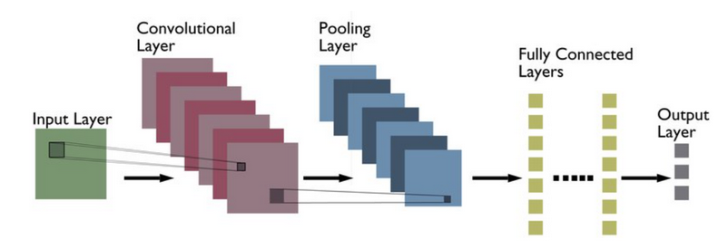
Figure 1: A typical CNN architecture [2]

Vision Transformers (ViTs), introduced by in 2020 in a paper “An Image is Worth 16×16 Words” [3], adapt the transformer architecture originally developed for natural language processing to vision tasks by dividing images into patches and processing them as sequences, achieving state-of-the-art performance in image classification and related computer vision applications.

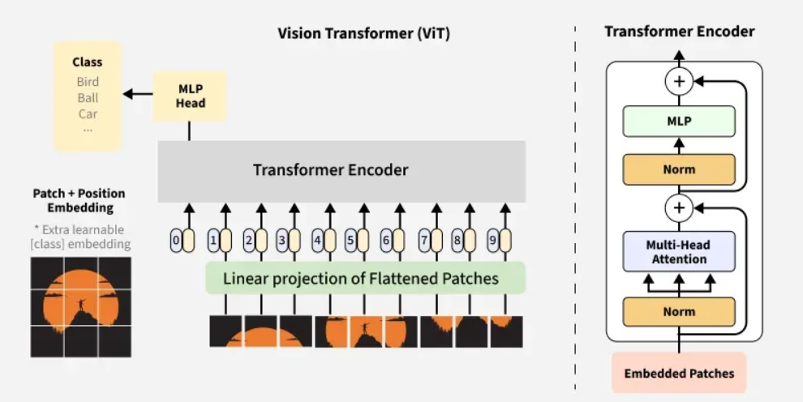
Figure 2: A typical ViT architecture [4]

2.2. CONVOLUTIONAL NEURAL NETWORKS (CNNs)
Convolutional Neural Networks are a class of deep learning models designed to automatically learn feature representations from structured, grid-based data, most common of which are images. They rely on stacks of convolution layers, which are the core component of a CNN, that apply learnable filters (or kernels) across the input to produce feature maps by capturing low-level patterns such as edges and textures, and progressively higher-level structures such as shapes and object parts.
These convolutional layers are typically separated by pooling layers (or downsampling layer), which reduce the spatial dimensions of feature maps by retaining the most important information through the use of operations such as max pooling or average pooling. As a result, computational cost and overfitting are reduced while encouraging invariance.
After multiple stages of convolution and pooling, the resulting high-level feature maps are flattened into a one-dimensional vector and is fed into one or more fully connected layers (or dense layer), where all neurons are densely linked to perform higher-level reasoning. These dense layers integrate information across the entire image and convert abstract spatial features into representations for final prediction, often regularized through dropout to improve generalization.

2.3. VISION TRANSFORMERS (ViTs)
Vision Transformers are a class of deep learning models the applies the transformer architecture to image analysis by converting an image into a sequence of fixed-size, non-overlapping patches, typically 16×16 pixels each. Every patch is flattened into a single vector and projected through a learnable embedding layer, forming a patch embedding that transforms the original 2D image into a 1D sequence of tokens suitable for transformer processing. Positional encodings are then added to these embeddings to supply spatial context, allowing the self-attention mechanism to retain information about each patch’s location in the original image and preserve the underlying 2D structure.
At the core of ViT is the self-attention mechanism, which allows the model to compute relationships among all patches simultaneously. Instead of restricting operations to local regions, self-attention evaluates pairwise interactions across the entire image, enabling the capture of long-range dependencies and global structural patterns that extend beyond localized neighborhoods.
Once the position-aware patch embeddings are prepared, they pass through a stack of transformer encoder layers composed of multi-head self-attention modules, which allowing every patch to directly communicate with all others regardless of distance, and feed-forward networks applied independently to each patch. Each layer is stabilized through residual connections and normalization, ensuring effective gradient flow and consistent training behavior.
A dedicated CLS token is prepended to the patch sequence before entering the encoder. This token interacts with all patches through self-attention, gathering and accumulating global information from the full set of image patches. After the encoder stack, the final embedding of the CLS token represents a holistic summary of the image. This embedding is then passed to a lightweight multilayer perceptron (MLP) head, typically consisting of one or two fully connected layers followed by a SoftMax activation for classification tasks or a linear layer for regression tasks, producing the final prediction of the model.

2.5. Proposed Hybrid ViT + CNN Architecture (DRAFT)

The proposed architecture blends the strengths of convolutional networks and transformer-based models to optimize mushroom classification accuracy. The system processes input images through two parallel branches and employs fusion, gating, and attention mechanisms before final classification.

The hybrid ViT + CNN model integrates global and local feature representations through a sequence of attention-based and gating mechanisms. These components form the central innovation of the architecture, enabling more discriminative feature extraction in visually complex mushroom species.

2.5.1. Architectural Overview
The model consists of the following components:
- CNN Feature Extractor (MobileNetV3 backbone)
Extracts lightweight local spatial features such as textures, edge patterns, and fine structural details. It outputs a feature map with high spatial resolution and low computational cost.
- ViT Feature Extractor
Converts the image into a sequence of patches and applies multi-head self-attention to capture broad contextual relationships and long-range dependencies.
- Feature Alignment Layer
Projects CNN feature maps and ViT token embeddings into a compatible dimensional space for downstream fusion.
- Gating mechanism
The gating mechanism regulates the contribution of CNN-derived features and ViT-derived features. It computes a learned weight vector that dynamically adjusts how much each feature source influences the fused representation. When CNN features provide clearer local details—such as gill spacing or cap texture—the gate shifts weight toward the CNN branch. When global structure or shape relationships dominate, the gate assigns more emphasis to ViT features.
This adaptive weighting improves robustness, especially in cases where mushroom species share similar textures but differ in subtle global cues, or where environmental noise (e.g., background foliage, lighting) may affect one branch more than the other. The gating mechanism ensures the model maintains stable predictions by leveraging the most reliable feature stream for each sample.
- Multi-Head Attention
Multi-head attention operates on the sequence of token embeddings produced by the ViT branch. Each attention head independently computes relationships between tokens by assigning attention weights, allowing the model to capture multiple types of global dependencies across the entire image. When combined, these heads create a richer, multi-perspective representation.
Within the hybrid model, multi-head attention plays a key role in aligning ViT features with CNN feature maps. Since CNN outputs reflect localized spatial patterns and ViT outputs reflect global contextual patterns, multi-head attention provides a flexible way to project both sources into a shared representational space, enabling the system to mix them effectively during fusion.
- attention fusion module
The attention fusion module combines gated CNN and ViT representations into a unified feature vector. It applies attention-based weighting to integrate both global and local information, ensuring that the final representation captures fine-grained textures while still considering overall structural relationships. This fused feature space is particularly important for species that appear superficially similar yet differ in minor morphological characteristics. By preserving complementary aspects from both architectures, the module enhances the system’s discriminatory power.
- Non-Linear Classifier
A fully connected classification head with activation functions (e.g., GELU), dropout, and normalization layers, producing the final predicted class.

2.5.2. Fusion Logic
After feature extraction, the model performs:
- Dimensional projection of both feature sets
- Gating to determine relative weighting
- Attention-based fusion to emphasize informative features
- Aggregation into a single embedding vector for classification
This process ensures that both local patterns and global layouts are effectively captured in the final representation.

2.5.3. Optimization Strategy
Full fine-tuning is performed using AdamW, allowing both branches and the fusion module to adapt jointly. AdamW’s decoupled weight decay improves stability and reduces overfitting, especially in hybrid architectures.

2.5.4. Comparison With Baseline Models
The hybrid architecture outperforms the CNN-only and ViT-only baselines due to its ability to:
- Combine local texture cues (CNN)
- Interpret global shape and contextual cues (ViT)
- Dynamically adjust reliance on each via gating
- Preserve complementary features through attention fusion
This synergy is particularly effective for mushroom species where visual distinctions involve both fine details and global morphology.

2.5.5. End-to-End Processing Flow
The classification pipeline proceeds as follows:
- Input image received from mobile device
- CNN branch extracts local spatial features
- ViT branch generates global patch-based embeddings
- Features pass through alignment and gating modules
- Attention fusion constructs a unified representation
- Classifier outputs the predicted mushroom species

2.7. Dataset Preparation

Equivalent to their “Data Collecting” + “Dataset” + “Annotation” + “Augmentation.”

2.7.1 Data Collection

Explain:

No self-collection

All dataset sources (list each source clearly)

2.7.2 Dataset Structure

Explain how your dataset is organized into:

Train

Validation

Test

Labels CSV

2.7.3 Data Cleaning / Preprocessing

Describe basic steps:

Remove corrupted images

Remove mislabeled samples if any

2.7.4 Data Augmentation

List each transformation used in Albumentations.
Example: RandomCrop, HorizontalFlip, ColorJitter, Normalize, Resize, etc

2.7.5 Annotation (if applicable)

Only include if your dataset required manual label verification.
If not, remove the section entirely.

2.8. Model Training Setup

Include for each experiment:

Input size

Batch size

Optimizer (AdamW)

Learning rate

Epochs

Scheduler

Hardware (GPU type)

Loss function

Evaluation metrics (accuracy, F1 score, etc.)

CHAPTER 3: IMPLEMENTATION
3.1. APP EVALUATION
3.1.1. …
3.1.2. …

3.2. MODEL EVALUATION
3.1.1. Evaluation metrics
3.1.2. Evaluation results
3.1.2.1. God forbit, I don’t know?

CHAPTER 4: CONCLUSION AND DEVELOPMENT DIRECTION

4.1. CONCLUSION
Throughout this thesis, I have deepened my understanding of machine learning theory, modern deep learning architectures, and associated tools. The proposed hybrid CNN-ViT model achieved accuracy and macro F1 scores comparable to the standalone ViT baseline yet exhibited slightly better generalization stability. It showed smaller per-class F1 deviations between validation and test, lower variance in these deviations, and fewer classes with large performance drops.
During training, the hybrid model also demonstrated a slightly smoother validation loss curves and more consistent convergence across multiple random seeds. The slight performance gains stem from the CNN component’s effective capture of local details, which complements ViT’s global contextual modeling, thereby reducing misclassifications observed in the pure ViT baseline.
Overall, the hybrid architecture proved more robust and reliable for fine-grained classification of the 80 mushroom species.

4.2. DEVELOPMENT DIRECTION
Due to time and computational resources constraints, I could not implement a large-scale data collection, extended model training, and additional feature development for the mobile application. Nevertheless, the current system provides a solid and scalable foundation. Thus, I propose some future development directions:
- Expansion of the scope to include other wild edible organisms (e.g., berries, wild root vegetables, and foraged leafy greens) by training additional or multi-task models as well as expanding the dataset to include other species (for searching feature).
- Refine data augmentation strategies to further mitigate overfitting and potentially increase classification accuracy.

REFERENCE
- Y. LeCun, L. Bottou, Y. Bengio, and P. Haffner, "Gradient-based learning applied to document recognition," Proc. IEEE, vol. 86, no. 11, pp. 2278-2324, Nov. 1998.
- A Kumar, “Different Types of CNN Architectures Explained: Examples”, Nov. 4, 2023. [Online]. Available: https://vitalflux.com/different-types-of-cnn-architectures-explained-examples/
- A. Dosovitskiy et al., "An Image is Worth 16x16 Words: Transformers for Image Recognition at Scale,", Oct. 22, 2020. [Online]. Available: https://arxiv.org/abs/2010.11929
- GeeksForGeeks, "Vision Transformer (ViT) Architecture”, Jul. 23, 2025. [Online]. Available: https://www.geeksforgeeks.org/deep-learning/vision-transformer-vit-architecture/
- 5
- 4
- 5
- 6

